Authors: Emilia Perez, Ahtziri Aguirre, Fernando Casillas, Resselly Rincon
Instructor: Jongwook Woo
Date: 04/28/2026

Lab Tutorial
Emilia Perez (jperez451@calstatela.edu)
04/28/2026

Creating a Bar Chart Using Kibana

Objectives
In this hands-on lab, you will learn how to:
- Obtain datasets using Kaggle
- Turn an excel file into an index/data view using Kibana
- Aggregate data using Kibana
- Create charts using Kibana

Platform Specs
- Acer Aspire A315-24PT
- CPU Speed: 2.8 GHz
- # of CPU cores: 8
- # of Nodes: 1
- Total Memory Size: 16 GB

Step 1: Obtain the Dataset using Kaggle
This step is to obtain the dataset needed to begin the process of turning it into a chart.
- Open your browser and in the search bar, enter https://www.kaggle.com/
- Click on ‘Register’ in the top right corner, and then click on ‘Register with Google’ or ‘Register with Email’ based on your preference



- Finish the sign-up process and then go to https://www.kaggle.com/datasets/iamsouravbanerjee/airline-dataset
- Click on Download in the top right corner, then click on ‘Download dataset as zip’
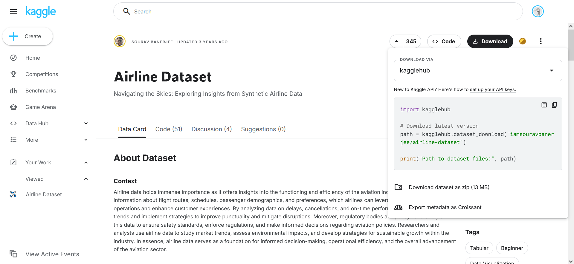

- Open your File Manager, then go to your downloads page

- Right click on the archive.zip folder, then click ‘Extract all’ and ‘Extract’ on the next window pop-up
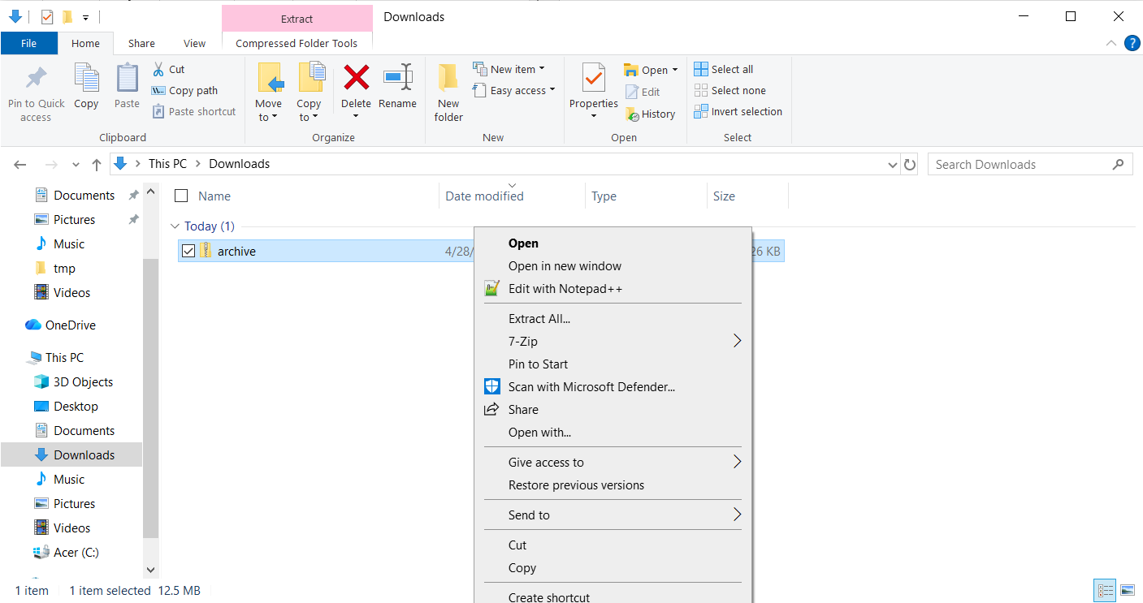
- You will now have a folder with 3 data sets, the one we will use is ‘Airline Dataset Updated – v2’

Step 2: Upload the Dataset to Kibana
This next step is to upload the excel dataset to Kibana to easily create new charts
- Log into Elastic with your credentials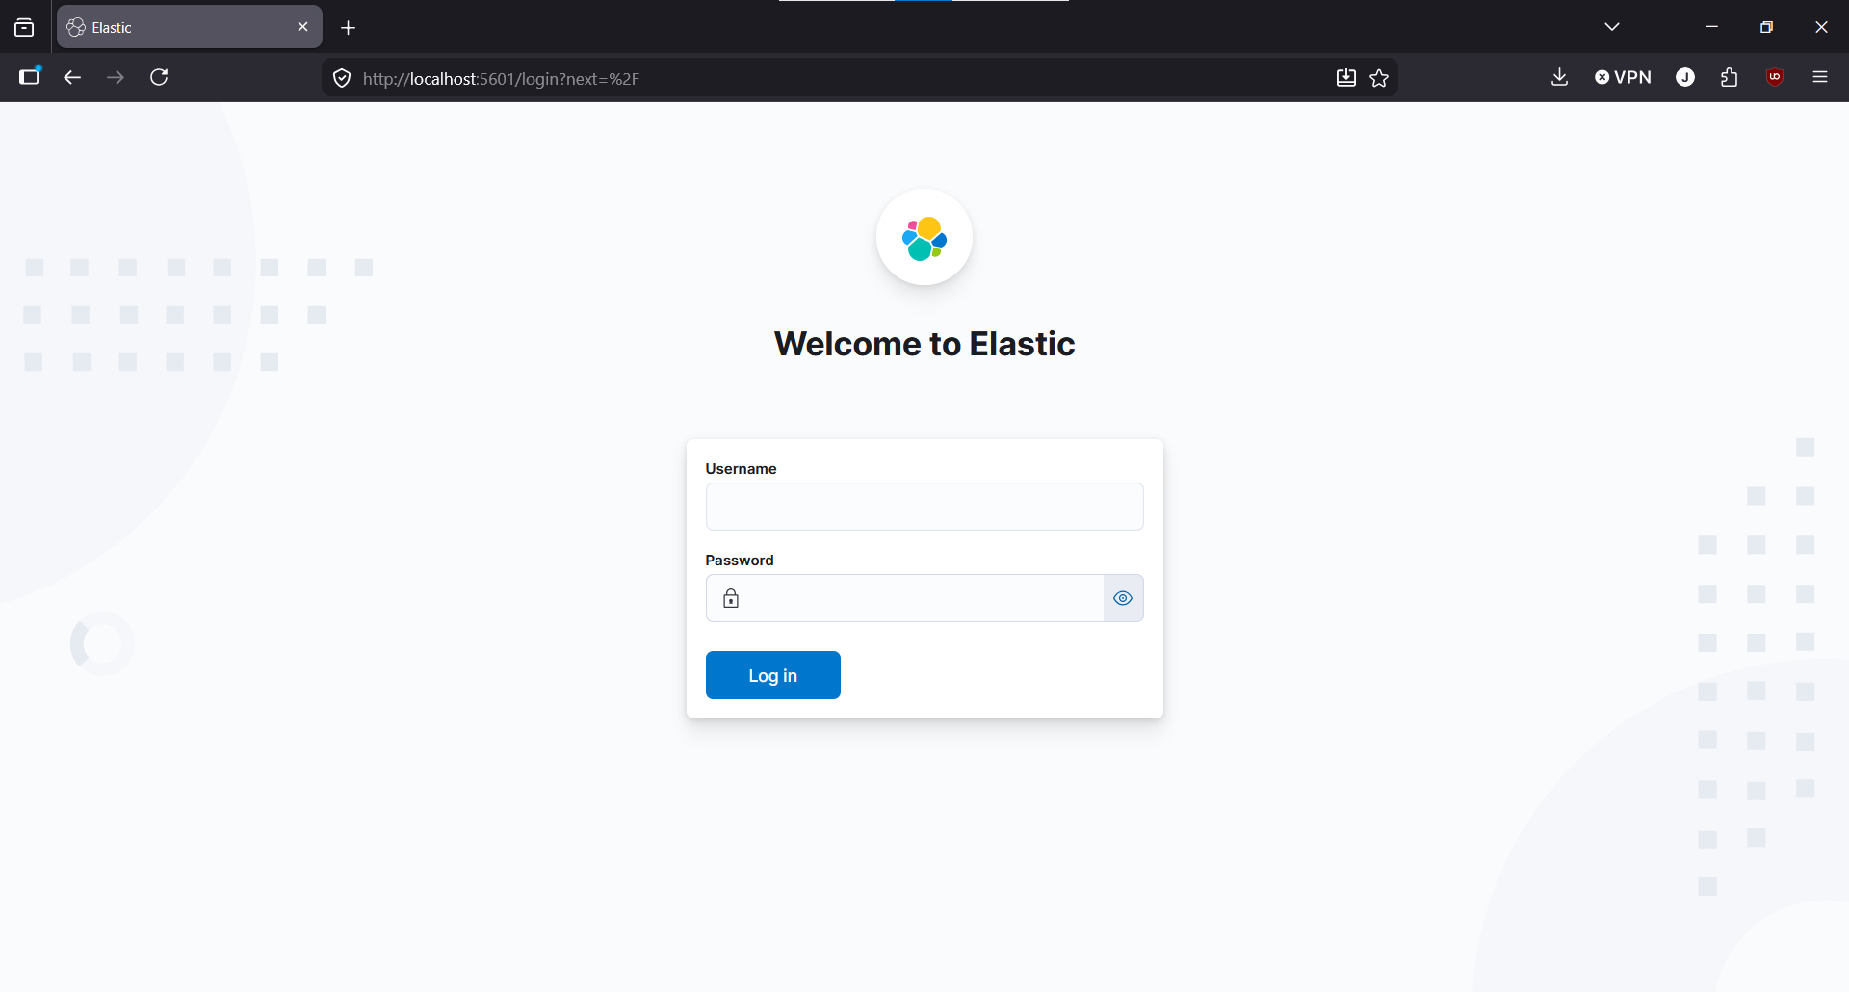
- Open the sidebar on the left-hand side of the screen and click on ‘Machine Learning’ underneath the ‘Analytics’ Section
- Click on Data Visualizer and you will be asked to select a file
- Open the unzipped ‘archive’ folder and select ‘Airline Dataset Updated – v2’
- If all the steps were done correctly, you should see the following:
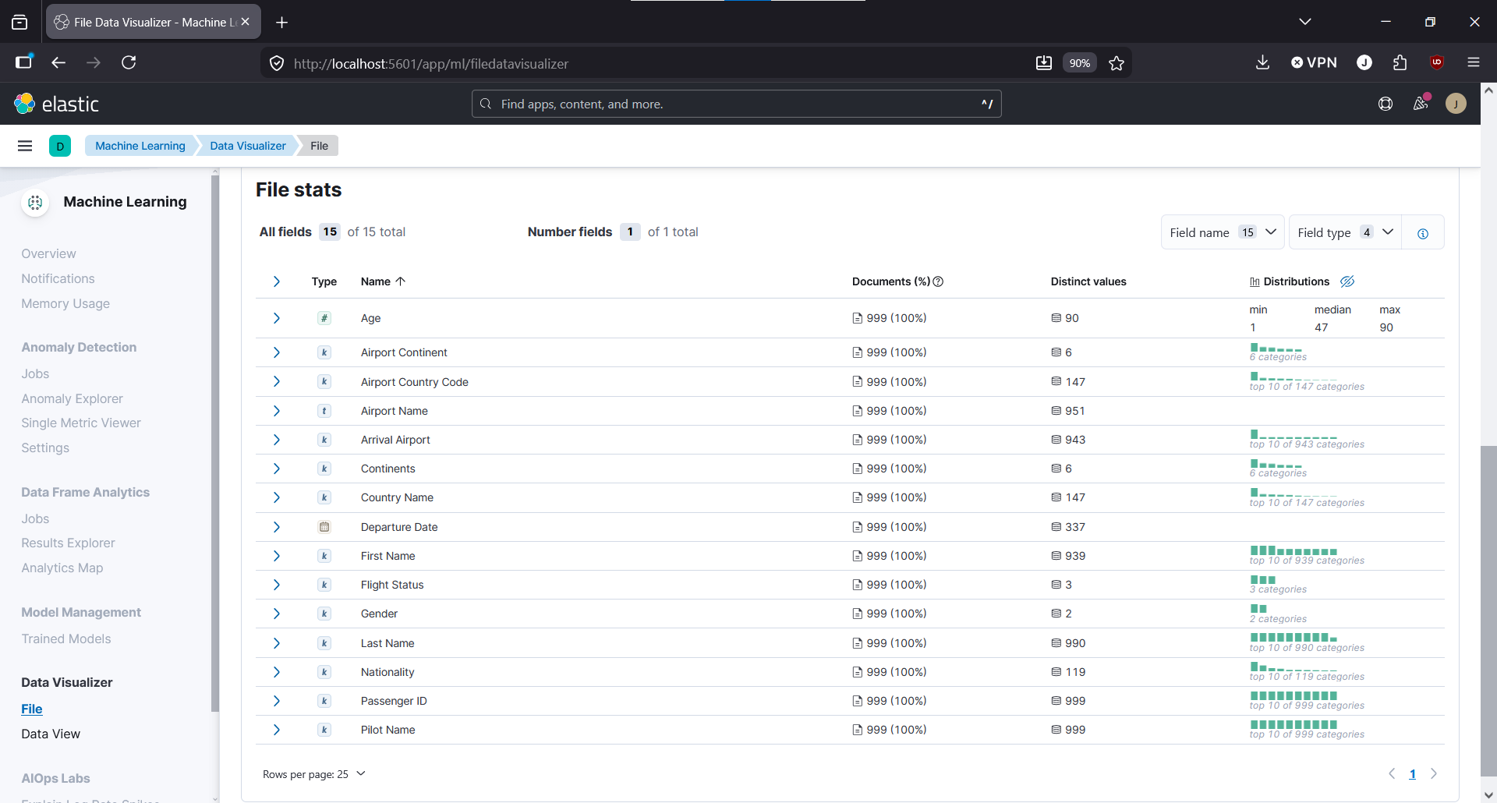
- Click on import and for the index name, type ‘airline-dataset’ and make sure that the ‘Create data view’ box is checked
- Once complete, click on ‘View Index in Discover’ to verify that it was done successfully

Step 3: Visualizing the Dataset with Kibana
- Still on Kibana, open the sidebar on the left-hand side of the screen and click on ‘Visualize Library’ underneath the ‘Analytics’ Section
- Click on ‘Create new visualization’ then click on ‘Aggregation Based’ and finally click on ‘Line.’ Afterwards, for the dataset make sure you are using the Airline one we had just made.
- Under the Y-Axis, make sure that ‘Aggregation’ is set to ‘Average and field is ‘Age.’ Rename the custom label to ‘Age’
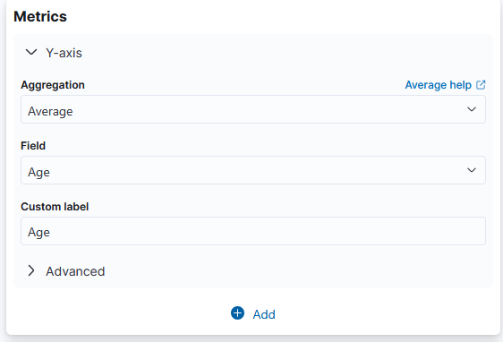
- Under Buckets, click on ‘+ Add’ and select ‘X-Axis’
- Set Aggregation to ‘Date Histogram and the ‘Field’ to ‘Departure Date.’ For the custom label, name it ‘Average Age of Fliers on Departure Dates.’
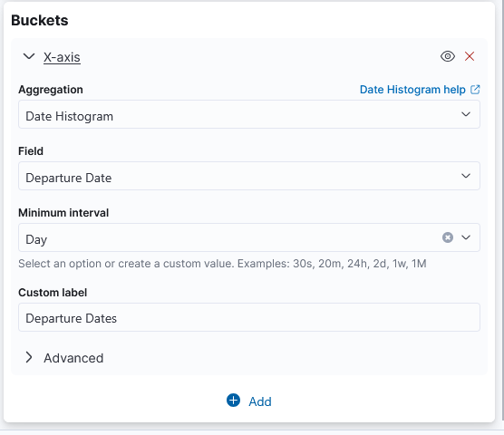

- In the top right corner, set the start time to be ‘Jan 1, 2022 @ 00:00:00.000’ and end time to be ‘Dec 31, 2022 @ 23:30:00.000’ Make sure that these values are set to Absolute.
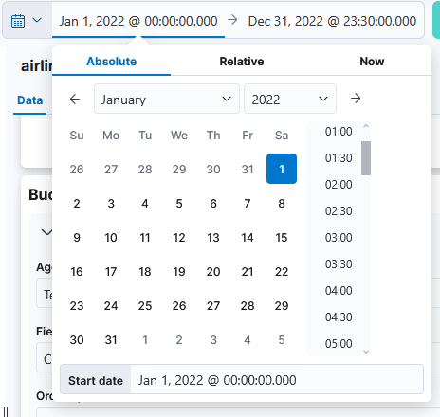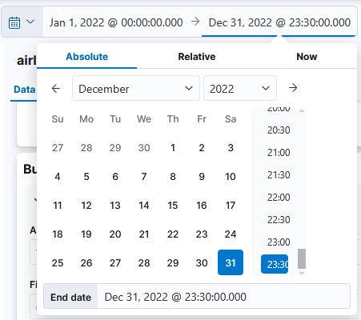
- Your chart should now show the average age of fliers over the course of a year. If you notice, the line is steady between 40 and 50 years which means that it is generally older people flying.
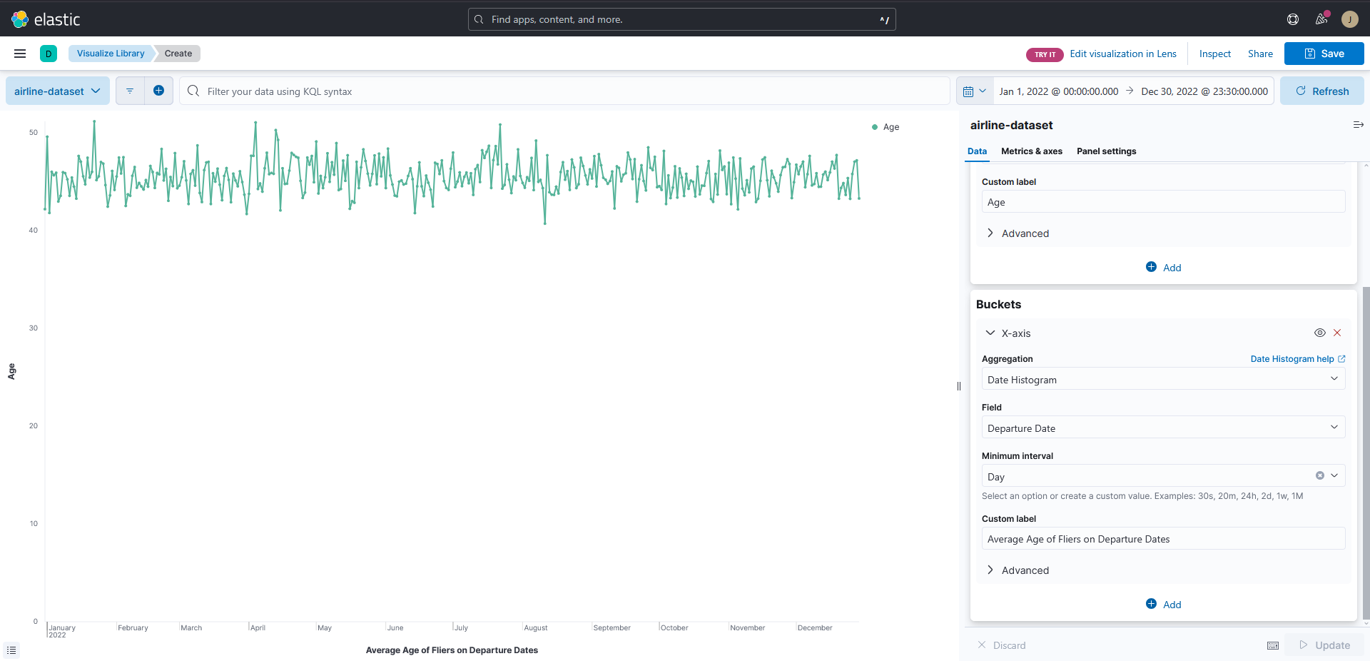
References
- Data Source: https://www.kaggle.com/datasets/iamsouravbanerjee/airline-dataset
- GitHub: https://github.com/StrayBerry512/CIS-3200-Final

